**White Paper**

**Web-based Machine Learning Application**

Machine learning has been a hot topic in the news during recent years. However, only people who are working and study on computer science or a related field can learn machine learning and use it. However, machine learning shouldn’t be limited to these group of people. A web application with some machine learning algorithm, including guilds so that people can easily train some models for themselves. was proposed to be created. The main purpose of this project is to provide the public an easy access to machine learning and data optimize. A secondary purpose is to introduce people who are interested in machine learning in this area.

1. **Problem**

In daily life, people are facing all kind of data and make decisions based on them. However, human does not have the ability to take all these information into consideration. Sometimes, they need tools to help them build models and make predictions to help them make choice. Though people are reading news about machine learning and artificial intelligent every day, there aren’t many tools for the public to use. What they need is just some application to input the data they have. After using machine learning, they can use the model they build to make predictions. People need and want to have some tool to perform the data they have. For example, some people have some information about the price of their neighbors’ house, and they want to know a reasonable price to sell their house.

The second problem is that there are few applications nowadays can introduce people who are interested in machine learning in this area. There are two methods that people can try to get access to machine learning. One is taking a machine learning course; however, it requires a strong knowledge of calculus, linear algebra, statistic, and coding skill. Another way to try machine learning is using some libraries, which are some codes that other programmer had built. The problems are that those who use libraries cannot have a thorough understanding of machine learning, and it also requires high programming skills.

1. **Solution**

This web-based application works with two parts, which are the back-end algorithms and the front-end web pages. When users input the data they have, the front-end webpage, as shown in figure 1, can collect the data and transfer those data to the server. After that, the server will use these data to build a model with the back-end algorithms (figure 2), which is something like a math function. When the model has been built, the user can use it to make predictions. One of the advantages this project has is that the website is something people can easily use, and there is no programming skill required in this process.

A screenshot of a social media post

Description generated with very high confidence

Figure 1: front-end webpage (source: the webpage in this application under testing)

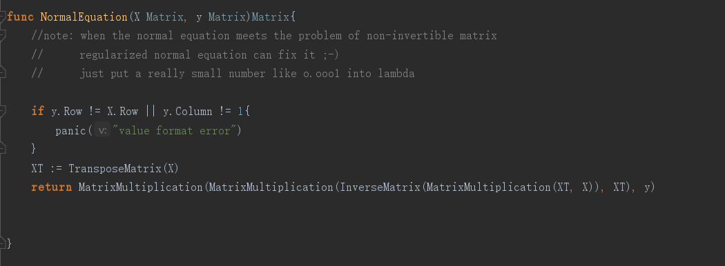

Figure 2: the back-end algorithm (source: the code under testing)

1. **How it solves the problem**

By using this web application, people can try to build models by themselves. People without coding skill can easily use it by inputting data into the cells and clicking the button. After that, the result will be illustrated on the webpage. There are also some instructions and examples that can help people know how to use this webpage. Also, after trying this fantastic website, some people may be attracted in machine learning and start to study how it works and how to let the machine learn something by itself. People will be surprised by how smart the computer is. With this web application, everyone can easily use it to build models for whatever they want in any time and any place. The amazing algorithm will help people use their data wisely and help them make decisions in the future. People will enjoy the feeling that the computer truly working for them with the computer’s intelligence. On the other hand, this project does have limitations. For example, people can only use the linear regression algorithm, which means that the user can only build a linear model which can hardly solve some logical problem. However, it is not an essential problem for beginner to try machine learning.

In conclusion, this web-based machine learning application is an easy-access and easy-using project that can help people in the world to try machine learning and enjoy it.